ONBOARDING
TOOLING GUIDE FOR ONLINE CHANNELS ACCESS

“YOU ARE JUST A FEW STEPS AWAY FROM GROWING YOUR COMPANY”



Table of Contents
ONBOARDING
TOOLING GUIDE FOR ONLINE CHANNELS ACCESS
Table of Contents
Summary
1. Wordpress (CMS)
1.1 Intro
1.2 Instructions to access Wordpress website
Step 1 - Create a new user.
2. Google accounts
2.1 Analytics
2.1.1 Create
Step 1 - Go to analytics.google.com, click on sing-up and create a GA account via your (business) Google address or create one
Step 2 - In the next screen enter an account name and the URL of your website (for example: www.mijnwebsite.nl). Set the time zone and location to the Netherlands (important!). Finally click on "create account".
Step 3 - Installing GA can be done in various ways. We recommend that you always do this via Google Tag Manager. Instructions on Google Tagmanager can be found here. After creating the account, we can link the accounts.
2.1.2 Toegang verlenen
2.2 Google Ads
2.2.1 Create
2.2.2 Grant access
2.3 Tag Manager
2.3.1 Create
2.3.2 Grant access
2.4 Search Console
2.4.1 Create
2.4.2 Grant access
3. Facebook
3.1 Create a Facebook Business Account
3.3 Grant access
4. Mixpanel Analytics
4.1 Create account
5. Bing Ads
5.1 Create
5.2 grant access
6. LinkedIn Ad Account
6.1 Create Admin Page
6.2 Linked Ad Account + Add billing
7. Twitter Ad Account
7.1 Create ad account
7.2 grant access
8.1 Add user
9. Drip Email Account
9.1 Account Creation
9.2 Verifying your sending domain
10 Mailchimp
10.1 Create account and grant access
11 Instagram
11.1 Create account and share credentials
12. Youtube
12.1 Create a Youtube account
13. Snapchat ad
13.1 create account and grant access
14. Pinterest ad
14.1 create a Pinterest Ad account
15. TikTok
16. reddit
16.1 create a reddit Ad account and grant access
17. Hotjar
17.1 create a Hotjar account and grant us access
18. ActiveCampaign
18.1 create an AC account and grant us access
19. Autopilot
19.1 create an Autopilot account
20. Zapier
20.1 create an account and grant access

Summary
In order for us to execute our growth hacking skills, we’ll need access to your platforms. Note: some of these tools may be not of relevance for your company, this varies per industry. Let us know if something is unclear!

1. Wordpress (CMS)

1.1 Intro
Giving us access to the WordPress website is easy. By creating an account you give Sprints & Sneakers (accounts@sprintsandsneakers.com) your own login. In this way we can install plugins or pixels and (in consultation) add / optimize pages ourselves, using the correct rights.

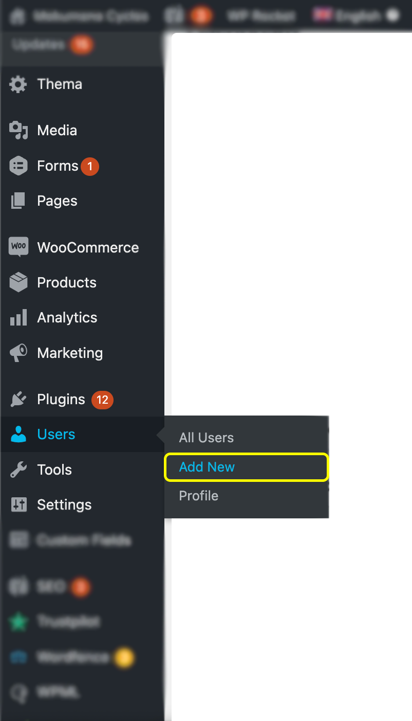
1.2 Instructions to access Wordpress website

Step 1 - Create a new user.
Step 2 - Enter all the details, make up a temporary password, check that you also send the details to us (accounts@sprintsandsneakers.com) and choose the role "administrator".

2. Google accounts

2.1 Analytics

2.1.1 Create
Step 1 - Go to analytics.google.com, click on sing-up and create a GA account via your (business) Google address or create one

Step 2 - In the next screen enter an account name and the URL of your website (for example: www.mijnwebsite.nl). Set the time zone and location to the Netherlands (important!). Finally click on "create account".

Step 3 - Installing GA can be done in various ways. We recommend that you always do this via Google Tag Manager. Instructions on Google Tagmanager can be found here. After creating the account, we can link the accounts.

2.1.2 Toegang verlenen
Step 1 - Click Admin and navigate to the desired account / property / view.

Step 2 - In the Account, Property, or View column (depending on whether you want to add the user at the account, property, or view level), click User Management.

Step 3 - In the Account Users list, click + and click Add New Users.

Step 4 - Enter the email address: accounts@sprintsandsneakers.com

Step 5 - Select Notify New Users by Email to have an email sent.

Step 6 - Give the user Administrator rights. More information about rights.

2.2 Google Ads

2.2.1 Create
Step 1 - Click here to create an Ads account.

Step 2 - Enter the email address you want to use to login, add a payment method and choose the correct time zone & currency.

Step 3 - Settings about conversion tracking, ad groups, etc. can be skipped.

2.2.2 Grant access

Step 1 - Find your account ID in the top right corner of your account by clicking the person icon. Your Google Ads account ID is in the following format: xxx-xxx-xxxx.

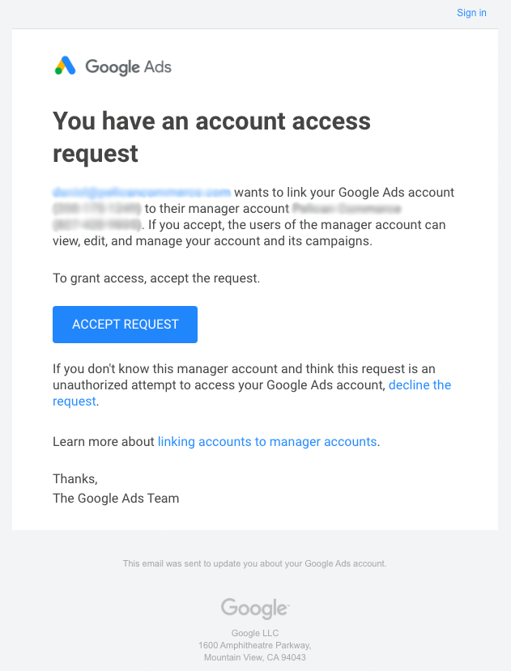
Step 2 - Send the account ID to us at privately.

Stap 3 - We will request access to the account through our management account (see the email below as an example). By accepting the request, we can further set up the account.

2.3 Tag Manager

2.3.1 Create

Step 1 - Go to tagmanager.google.com and create an account

Step 2 - In Google Tag Manager, click Workspace.

Step 3 - Look for your ID box at the top of the window. This has the format 'GTM-XXXXX'.

Step 4 -Click on your ID box to open the 'Install Tag Manager' box.

Step 5 - Place the <script> code snippet in the <head> tag of the HTML output of your web page, as close to the opening <head> tag as possible, but below any dataLayer entries. Place the <noscript> code snippet right after the <body> tag in your HTML output.

2.3.2 Grant access
Step 1 - Click the Administration tab, under Account, select User Management.

Step 2 - Click on the New button, enter the email address and give administrator rights to the email address.

2.4 Search Console

2.4.1 Create
Step 1 - Go to https://search.google.com/search-console and create an account

Step 2 - Follow Google's instructions to verify ownership of your domain.

2.4.2 Grant access

Step 1 - After verifying, login and go to settings via the left menu.

Step 2 - Then in the menu on the second place you see “Users and Permissions”, click on it.

Step 3 - At the top right you can add a user by “+ Add user”. Enter “accounts@sprintsandsneakers.com” “full permission” here.

2.6 Google Optimize

2.6.1 create an account
Step 1 - Go to optimize.google.com.
Step 2 - Click Create new Account.
Step 3 - Enter an Account name and a Container name.
Step 4 - Agree to the Optimize Terms of Service and click CREATE.
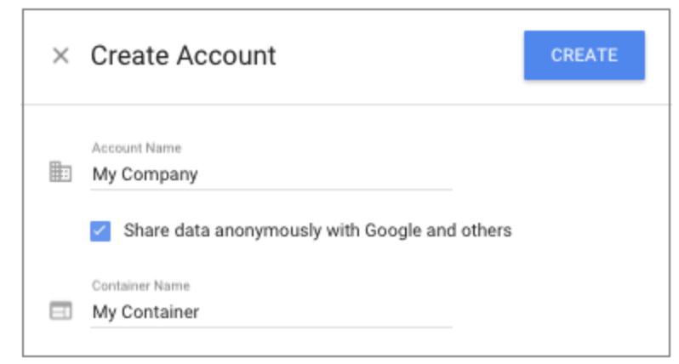
2.6.2 grant access
Step 1 - go to your Optimize account.
Step 2 - Click the Add user button to reveal the User details panel.
Step 3 - Enter the email address.
Step 4 - select Admin role, click DONE.

3. Facebook

3.1 Create a Facebook Business Account
Step 1 - Go to facebook.com/pages/create.

Step 2 - Under “Business or Brand” click on the Get started button

Step 3 - enter your business information, click continue, then upload your profile and cover images

Step 4 - create your username

Step 5 - click on Edit Page Info and fill in your business details

3.2 Create - Facebook Business Manager

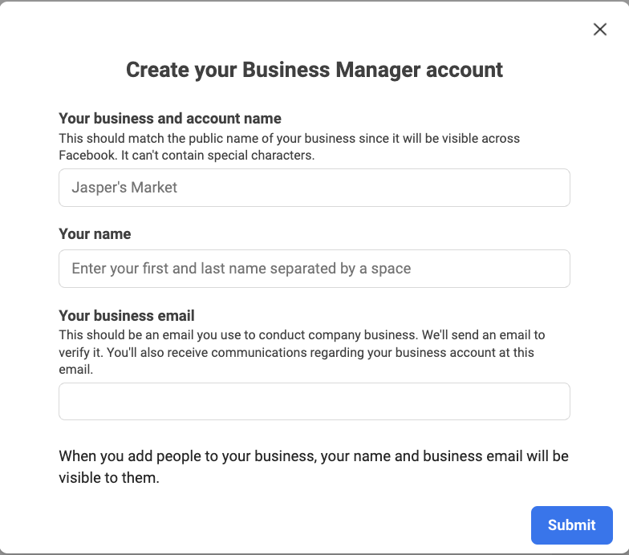
Step 1 - Go to https://business.facebook.com/ and click on create an account

Step 2 - Enter your company name

Step 3 - Enter your business email address

Step 4 - Note: Do not enter your personal email address as you want to keep your personal and professional accounts separate.

Step 5 - You will be redirected to your newly created Business Manager. Then add a page or ad account.

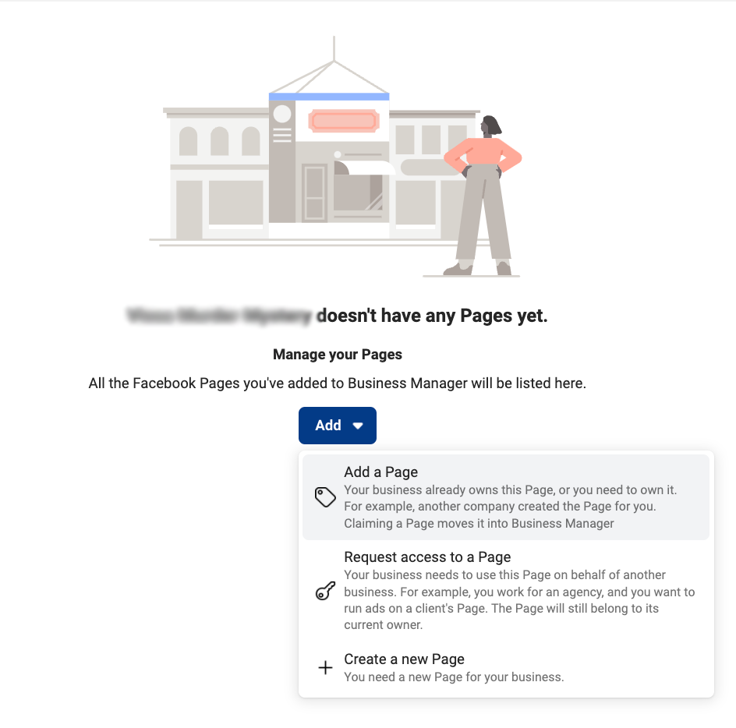

Step 6 - Go to Ad Accounts and create an advertising account. Note: when creating an account, immediately set the correct time zone + currency (this cannot be changed later)
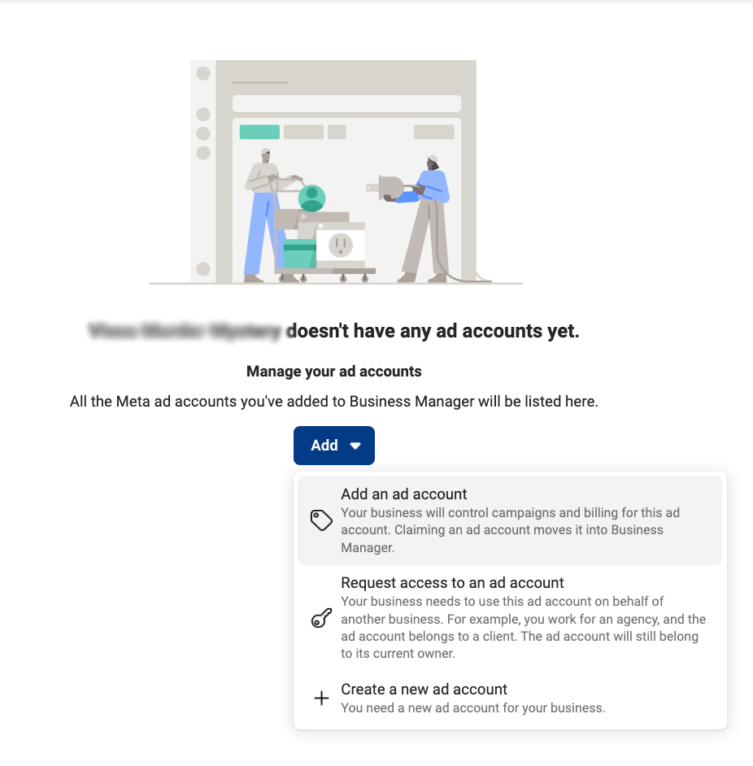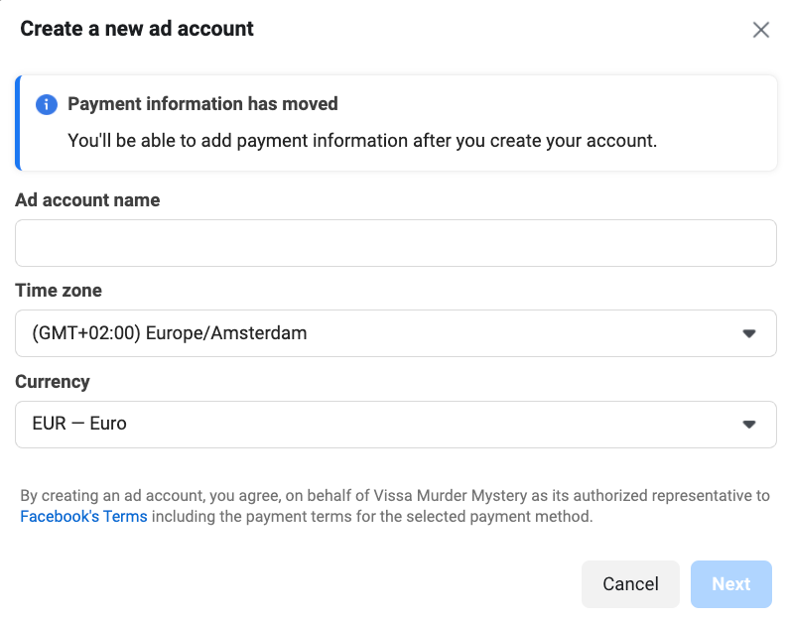

3.3 Grant access

Step 1 - Go to Business Settings, click on your Partners (under Users).

Step 2 - Click under Partner to share assets with on Add

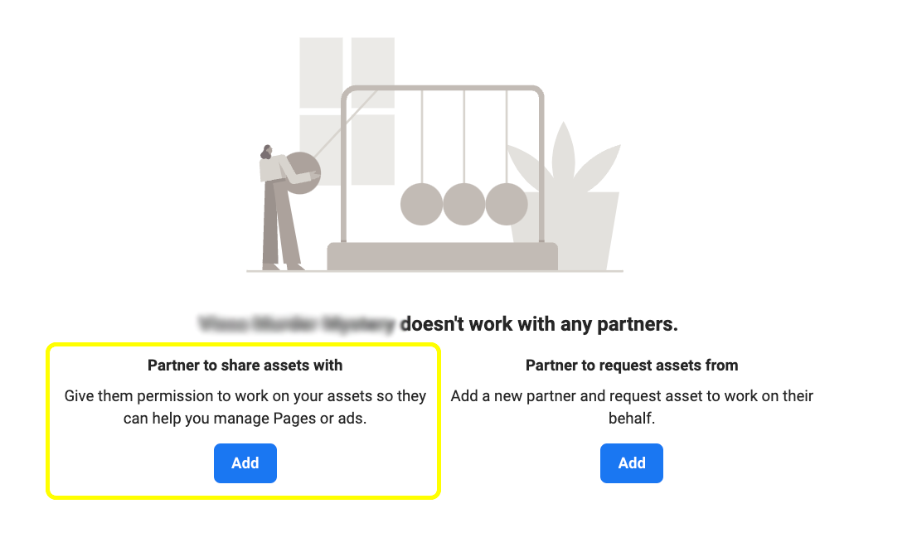
Step 3 - Enter the company ID of Sprints & Sneakers in the popup screen: 187500493833634

Then select the desired access. Select every asset type, the asset type name and Full Access. For instance: select Ad accounts, select Name, select Manage Ad Account, under Full control. Do this for every asset type and click on Save Changes.

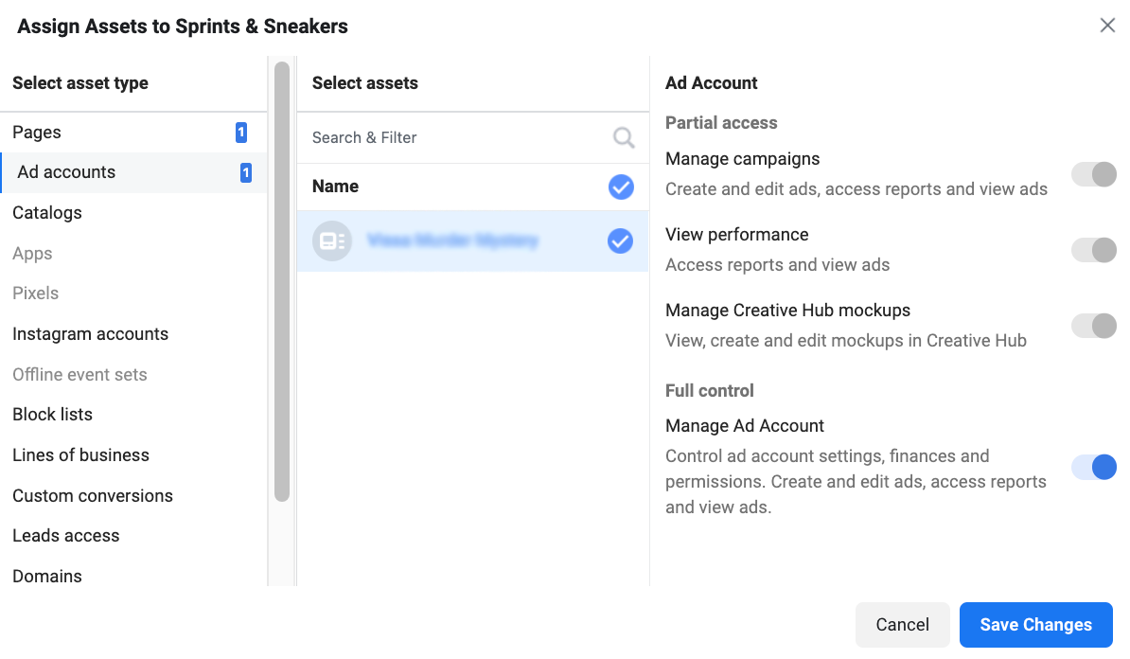

After this, we partner with your Facebook assets, including your page, ad accounts, catalogs, pixels, leads access, custom conversions, etc.

4. Mixpanel Analytics

4.1 Create account
Step 1 - Go to: https://mixpanel.com/ and press Sign-up

Step 2 - Enter your details such as "full name", "email", choose your password, "Organization", "phone number", "amount of employees", and select your role. Then click “Get Started”.

Step 3 - After you have logged in, click on the menu at the top right and then on “Invite users”. Add here to the email from “accounts@sprintsandsneakers.com” with Organization role “owner”, project “my project”, project role “owner”.
Do not use the invite member option on the "get started" screen!

5. Bing Ads

5.1 Create

Step 1 - Go to: https://bingads.microsoft.com/ and click on “Sign up for Bing Ads”.

Step 2 - Enter your details for the ad account. In the section “Primary use” choose the option “Promote this business”.

Step 3 - Select the option “Create a new campaign” instead of import from Google.

Step 4 - Scroll all the way down and press “Skip campaign creation” next to the “Save” button.

Step 5 - Enter the address details of your company. Please note, also enter your VAT number here!

Step 6 - Add your payment option too.

5.2 grant access
Step 1 - Click on the tab at the top left and click on “Accounts & Billing”

Step 2 - Copy your “Account number” and send it to us. We will then send you a request to manage your account as an agency.

Step 3 - Open your email and click on the link that gives us access.

6. LinkedIn Ad Account

6.1 Create Admin Page
Step 1 - Add me on LinkedIn (https://www.linkedin.com/in/NAMES&Semployee), send me a message so that I can accept you immediately.

Step 2 - Go to your page, then to the admin page.

Step 3 - At the top right of admin tools click on manage admins, then add me as page admin.

6.2 Linked Ad Account + Add billing
Step 1 - Click on “Work” at the top right

Step 2 - Click on advertise, then click “Create Ad”.

Step 3 - Add a new account at “Create account”.

Step 4 - Enter your Account name “Your company name”, choose the zone and currency and copy paste the URL of your LinkedIn page.

Step 5 - Click on the tab with the ad account name in the top right corner, then on “manage access”.

Step 6 - By clicking “edit” and “Add user to account” you can add me as “Account Manager”.

Step 7 - Note, make sure you add “Billing” yourself. Until you add the billing, Linkedin will not track anything!

7. Twitter Ad Account

7.1 Create ad account
Step 1 - Login to your Twitter account and send the login details to hello@sprintsandsneakers.com

Step 2 - After logging in click on your profile at the top left and press “Twitter Ads”, accept and click to let go.

Step 3 - Click on awareness as campaign option, then set the budget to € 1 and click on Next (Campaign)

Step 4 - Click on Next (Details), Next again (targeting), then click on creative and then again on next (creatives).

Step 5 - Click - Launch campaign

Step 6 - Choose your tax status, Click on the relevant option (often Business), then fill in your company details, and click next.

Step 7 - Click on your VAT ID (Yes), and enter your VAT details, then select the option “No” on the question “Are you an agency buying on behalf of an advertiser?”.

Step 8 - Add your billing information. And then click “Continue to my campaigns”. And switch off your awareness campaign.

7.2 grant access
Step 1 - Click on your company name at the top right, and select “Edit access to account”.
Step 2 - Give access to accounts@sprintssneakers, select “Account Administrator”, then select the checkbox “Can compose promotable tweets”, and click save changes.

8. Hubspot CRM Account

8.1 Add user
Enter accounts@sprintsandsneakers.com as a user using the following instructions. Give us full usage rights for the marketing part.

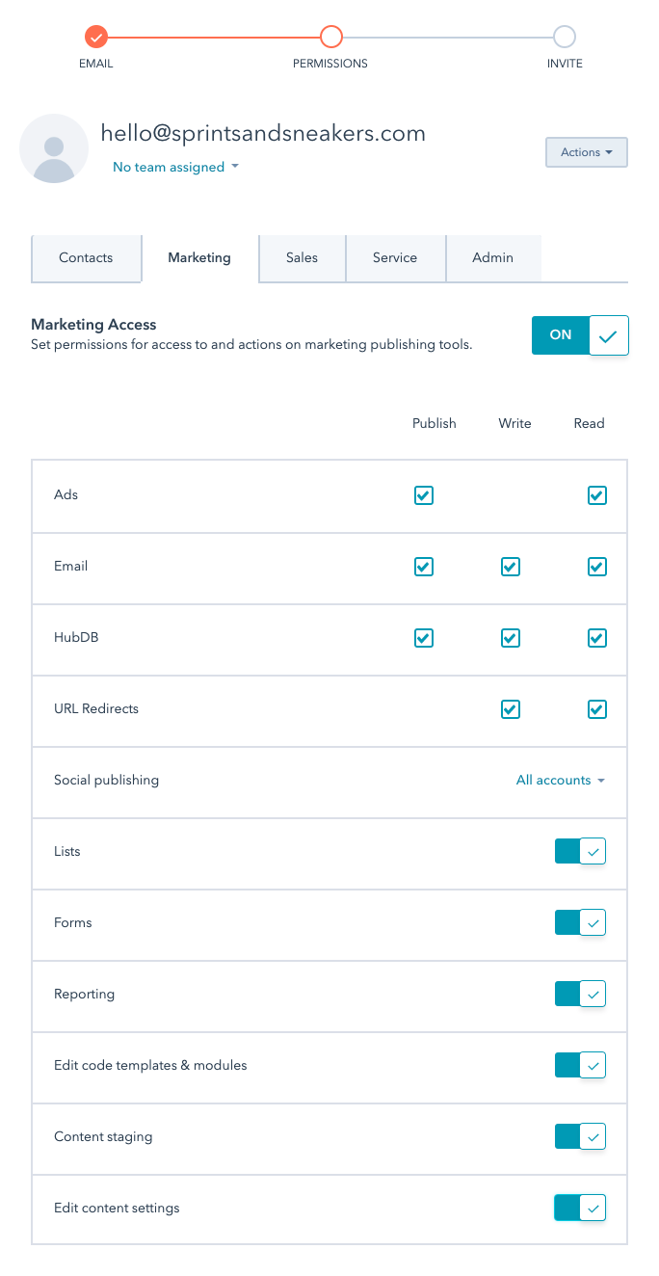

9. Drip Email Account

9.1 Account Creation

Step 1 - Go to https://www.drip.com/ and click on "Join Drip for free". You then enter your personal and company details. And click through.

Step 2 - Enter your credit card details. And click “Dive into Drip”.

Step 3 - Share the information where you come from, in terms of E-commerce stores, and fill in all company details. (We can always adjust this later!). Finally click “Start exploring Drip”

Step 4 - Click on the three dots at the top right and then on “account”. Then in the left menu choose members. Then add accounts@sprintsandsneakers.com as Admin.

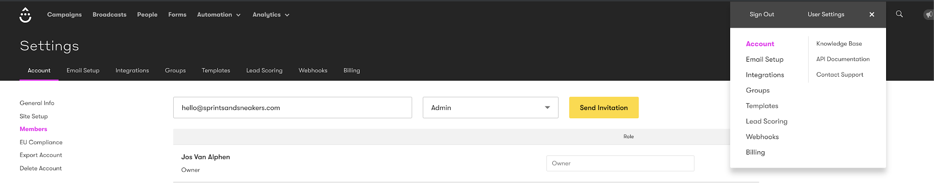

9.2 Verifying your sending domain
For domain verification, contact either your developer or give us access to your hosting provider for DNS authentication.

10 Mailchimp

10.1 Create account and grant access

Step 1 - Go to https://login.mailchimp.com/signup/ and then create an account.

Step 2 - Log in and go to account at the top right. Then go to settings and click on users.

Step 3 - You will see "invite a user" on the right of the screen. Add accounts@sprintsandsneakers.com here as an "Admin" user. In this way we have full access to the Mailchimp account.

11 Instagram

11.1 Create account and share credentials

Step 1 - create an instagram account

Step 2 - Go to your profile and tap the menu icon in the top-right corner and tap settings

Step 3 - click on Account, then tap Switch to business account.

Step 4 - connect your business account to your Facebook Page that is associated with your business

Step 5 - Add details, such as your business category, contact information and billing.

Step 6 - Tap Done.

Step 6 - Share your account credentials with us

12. Youtube

12.1 Create a Youtube account
Step 1 - Sign in to YouTube on a computer or using the mobile site.
Step 2 - Go to your channel list.
Step 3 - Choose to create a new channel or use an existing Brand Account:
  - Create a new channel by clicking Create a new channel.
  - Create a YouTube channel for a Brand Account that you already manage by choosing the Brand Account from the list. If this Brand Account already has a channel, you can't create a new one—you'll just be switched over to that channel if you select the Brand Account from the list.
Step 4 - Fill out the details to name your new channel and verify your account. Then, click Done. This creates a new Brand Account.

12.2 Grant Access
Step 1 - On YouTube, sign in as the owner of the Brand Account.
Step 2 - In the top right, click your account settings
Step 3 - Under "Account," select Add or remove manager(s).
Step 4 - Click Manage permissions.
Step 5 - Enter your password and re-authenticate.
Step 6 - Invite new users and enter accounts@sprintsandsneakers.com email address
Step 7 - add me as manager
Step 8 - Select Invite and click on Done.

13. Snapchat ad

13.1 create account and grant access
Step 1 - Log in to Ads Manager.
Step 2 - Click the menu in the top corner and select 'Ad Accounts.'
Step 3 - Click ‘+ New Ad Account.'
Step 4 - Input your advertiser details: when asked whether or not you’re an agency buying ads on behalf of an advertiser, whether or not your ad account will run housing, credit, or employment ad, and whether you will use the ad account for political ads select “no”.
Step 4 - Click 'Account Details’ and fill out your ad account info. Note: account type, billing type, currency and time zone can not be changed after you created the account
Step 4 - click on “create account” and select payment method.
Step 5 - click on invite new members, fill in my name and my personal accounts@sprintsandsneakers email address and add me as account admin. Click on invite new member.

14. Pinterest ad

14.1 create a Pinterest Ad account
Step 1 - create a personal pinterest account
Step 2 - Click Add a free business account and click on get started
Step 3 - Follow the prompts to create your business account, fill in the details, then click on next
Step 4 - select the focus and the type of business, when asked if you want to run ads, select yes, click on next
Step 5 - click on X to go back to your profile
Step 6 - click Ads in the top left corner then select Overview to open the Ads Manager
Step 7 - click on the arrow next to your name and select create new ad account. Enter a name and a country and click on set up billing.
Step 8 - read and accept Pinterest’ advertising agreement
Step 9 - add payment information and click on save

14.2 Grant access

Step 1 - click Ads in the top left corner then select Overview to open the Ads Manager
Step 2 - click on the arrow next to your name and select the ad account you'd like to add people to, then click View account settings
Step 3 - Click Add people, enter accounts@sprintsandsneakers email address and add me as admin, then click on add to account.

15. TikTok

15.1 create a TikTok Ad account

Step 1 - go to https://ads.tiktok.com/i18n/signup/ and select your billing country/region and Business as type of account. Click on next.

Step 2 - Fill in email or phone number, create a password, get verification code, and agree to terms, click on "Sign Up"

Step 3 - Fill in your account details and agree to terms, click on "Register"

Step 4 - in your TikTok Ads Manager dashboard, click on the circle on the top right corner of the page, then select "Account Info" under 'Account Settings'. Then, click on "Business Information" under 'Account Setup' and fill in all the details.

Step 5 - Click on "Primary Contact" under 'Account Setup', then fill in the contact details for your ad account.

Step 6 - Click on "Tax Information" under 'Account Setup', then enter in your valid tax information (it will be used for invoicing and receipts)

Step 7 - Click on "Payment Method" beneath 'Account Setup'

15.2 grant access

Step 1 - Go to your TikTok Business Center account and click "Members" under Users in the navigation bar on the left, click on invite member.

Step 2 - enter my personal accounts@sprintsandsneakers email address and add me as admin, then click on next.

Step 3 - set ad account permission on ad account admin and click confirm.

16. reddit

16.1 create a reddit Ad account and grant access

Step 1 - go to https://www.reddit.com/adsregister?dest=https://ads.reddit.com and fill in all the details. Do not tick the advertising agency box.

Step 2 - go to the top right corner of your dashboard and click on your username to find 'Manage permissions'. Add me with my personal accounts@sprintsandsneakers email address as administrator.

17. Hotjar

17.1 create a Hotjar account and grant us access

Step 1 - go to https://insights.hotjar.com/register and create your account.

Step 2 - share your credentials with us, we will take care of the rest.

18. ActiveCampaign

18.1 create an AC account and grant us access

Step 1 - go to https://www.activecampaign.com/signup/ and fill in all the information. Click on create account.

Step 2 - Click "Settings" located on the bottom left corner of your account.

Step 3 - Click “Users” in the left menu and then click on the “Add User" button.

Step 4 - complete the fields and grant us admin rights

19. Autopilot

19.1 create an Autopilot account

Step 1 - go to https://app.ap3prod.com/-/signup , fill in your details and click on sign up

Step 2 - share your credentials with us, we will take care of the rest.

20. Zapier

20.1 create an account and grant access
Step 1 - go to https://zapier.com/sign-up/ and fill in your details. Choose the ‘Starter plan’

Step 2 - share your credentials with us.

